

|  |  |
| --- | --- |
|  | **Sacred Heart Catholic Primary School**  Cnr Waratah & Keenan Street, Mona Vale NSW 2103  T: (02) 9999 3264 W: [www.shmvdbb.catholic.edu.au](http://www.shmvdbb.catholic.edu.au) ⚫ E: [shmv@dbb.catholic.edu.au](mailto:shmv@dbb.catholic.edu.au) |

**Term 3 Week 1 - 25 July 2018**

**Term 1 Core Value:** **Justice**

**School Rule:** We show justice towards our self, others and the environment when we…

**Expectation of Behaviour:** Treat others the way you want to be treated

Dear Parents

*Lord, as we begin Term 3,*

*give us insight to see realistically "what is";*

*but make us dreamers and give us vision of all the possibilities for "what can be."*

*Grace us and grace our students with global vision in our mission to spread your love.*

*May we be trailblazers as we bring that "touch of magic,"*

*that touch of your love, to those we meet each day.*

*We make this prayer in your name, Jesus Christ.*

*Amen*

The beginning of a new term is a time of renewal and regeneration. The term promises to be filled with exciting learning opportunities and experiences for students and staff alike. To start the term off we welcomed Mrs Jemma Satchell back to Year 1S after her maternity leave and we welcomed Ms Edwina Ovens who will be working with Year 4D during her teaching practicum. We also welcomed a new student, Shintaro Gilbert to join Year 3-6S.

Celebrations are in order for Kindergarten who this week achieved their 100-day milestone of schooling. To celebrate, a ‘bike-and-scooter day’ has been organised for students in Kindergarten Friday 3 August. These students will be allowed to wear casual clothing on that day. Parents will be notified of the finer details of this celebration by the Kindergarten classroom teachers.

Facilities have been improved over the holidays with all classrooms being fitted with air conditioners. Over the coming weeks, the school grounds will be enhanced by new play equipment and plants.

A major focus for the school this term is the school review scheduled 18, 19 September. This experience will provide the school with the assurance that it meets regulatory requirements under the NSW Education Act (1990) and that the school provides a safe and supportive, yet challenging learning environment, underpinned by the mission of the Church.

For those who engaged with your children in the acting principal’s maths challenge – the answer is – a decimal point! Well done to Joe Cook (Year 6) who worked through this puzzle on his own.

As always, many thanks for your support of the school and feel free to contact me on any matter you wish to discuss at any time.

Kind regards

*Rosemary Vellar*

**Acting Principal**

Like and follow us at: [facebook.com/sacredheartmonavale](https://www.facebook.com/SacredHeartMonaVale/?fref=ts)

Like and follow us at: [twitter.com/SHMV16](https://twitter.com/SHMV16)

***Curriculum News***

Welcome back to term 3,

10 August is our annual Athletics Carnival at Narrabeen. Thank you to all parent volunteers who have offered to assist on the day. Please help out if you’re free on the day. We would really appreciate it. All students need to return their permission notes by Friday 27 July.

Public Speaking commences this term. Please refer to the Public Speaking information note sent home this week.

We encourage all our students to take part in the Young Writers Competition. You can enter online or at Mona Vale library.



**Caitlin Remeeus, Acting Assistant Principal**

***Important Census Information***

The Government requires that schools conduct a census of students as at Friday 3 August 2018. The information provided is used as the basis for the payment of the State Government and Commonwealth Government recurrent funding. The CSO also will also collect data from schools for anticipated student numbers to assist with the review of staffing and facilities requirements for 2019.

If you have a **CHILD NOT RETURNING** to Sacred Heart School in 2019, could you **please complete the form** in the following link and return to the school office **by Monday 30 July 2018**.

[August Census – 2019 Attendance Letter and Form](http://www.shmvdbb.catholic.edu.au/_uploads/ppage/files/2019%20Blank%20Next%20Year%20Attending%20letter%20to%20family(1).pdf)

**Please note: If you do not have a child leaving Sacred Heart at the end of 2018, you do not need to complete this form.**

***Sport***

**Athletics Carnival**

Athletic Carnival Notes and Permission Forms were sent home with your child on Monday. Please ensure you complete the forms and return to the office by this Friday, 27 July 2018. This will enable us to prepare appropriately and book the buses for the return trip back to school.

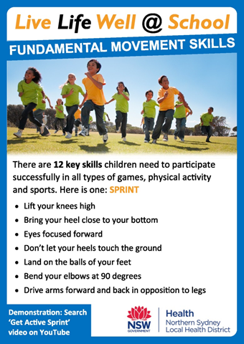

**Stephanie Munro – Sports Co-Ordinator**

***Lunch Club – Term 3***

Our popular lunch time clubs are up and running. Here is the schedule for this term. Please note that the Italian Club will resume week 4 of this term.

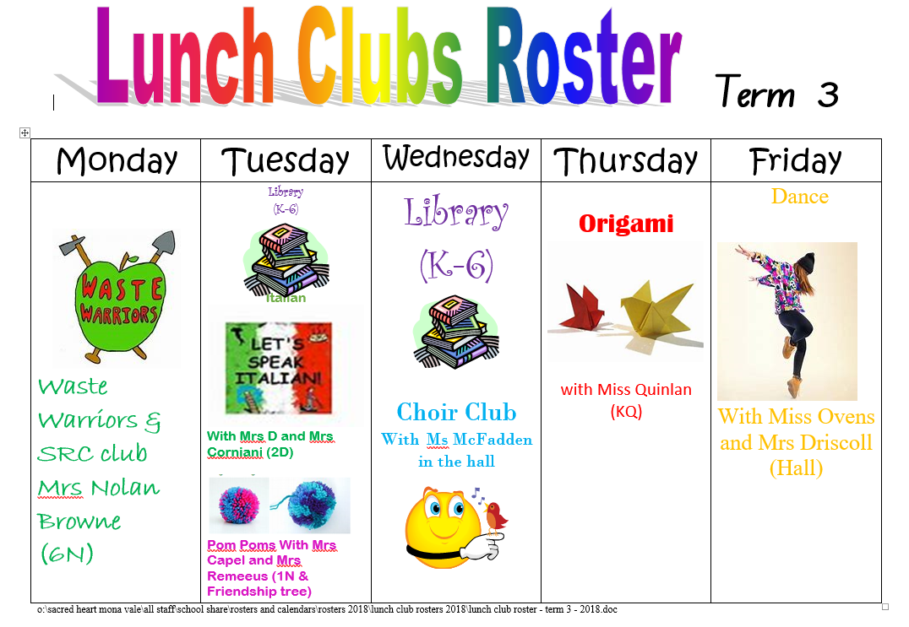

***Book Week – Save the Date !***

**SAVE THE DATE**: SACRED HEART BOOK WEEK CELEBRATIONS

**TERM 3, WEEK 4, AUGUST 13-17, 2018**

Book Parade: Friday 17 August

Each year it is our tradition to wear/create a costume representing our favourite character from a book or embracing the Theme, **“Find Your Treasure”**.

Poster Competition: Due 14 August

Children can make a poster with the **theme “Find Your Treasure”**, and that encourages the love of reading.

Prizes awarded to most original, must contain words: **“Find Your Treasure”**,  Name and Class.

Scholastic Book Fair: Monday 13 August-Friday 17 August.

***BUS ROUTE CHANGE***

Forest Coach Lines has advised us of the following change for the bus from Ingleside to school from 1 August 2018. (**Was School 141 and will become School 131**).

_____________________________________________________________________________________

Good morning All,

This email is to briefly inform you of a small change to the school bus 141 from Ingleside to your school, operated by Forest Coach Lines.

Due to changes in route number requirements by Transport for NSW planning the number of this route will change from School 141 to School 131 from 1 August 2018

There will be no change to the actual route the school bus travels nor the timing of it, ONLY the route number will changes.

If you have any queries, please do not hesitate to contact me.

Regards

**Sune Nielsen**

**Project Manager**

Forest Coach Lines Pty / Ltd

335 Mona Vale Road Terrey Hills NSW 2084

**P** 02 9485 0620

**M** 0411 407 448

**E** [snielsen@forestcoachlines.com.au](mailto:snielsen@forestcoachlines.com.au)

**W** [www.forestcoachlines.com.au](http://www.forestcoachlines.com.au/)

***Band News***

I hope you all had a lovely and relaxing holiday break. Miss Molly was extremely pleased with both Bands and Choir performances on Grandparents Day last term. I would especially like to thank the children for being the best they could be leading up to and on the day.

I would also like to notify Band and Choir parents of a change of training schedule on Wed 8 and Wed 15 August as follows, which will change to:

Thursday 9 and Thursday 16 August

Concert Band: (usual time of 7.45-8.45am)

Training Band: 8:45-9:45am

Choir 9:45-10:30am

Would you please ensure your musician is made aware of these changes.

**Clare McFadden, Band Co-ordinator**

***Happy Birthday***

[](http://www.google.com.au/url?sa=i&rct=j&q=&esrc=s&frm=1&source=images&cd=&cad=rja&uact=8&docid=NWmWfNe3hnrz2M&tbnid=QOJqXLb0a8T2jM:&ved=0CAUQjRw&url=http://www.clipartbest.com/belated-birthday-clipart&ei=XffOU_jfEou4uAT0-oLQAg&bvm=bv.71667212,d.c2E&psig=AFQjCNH4E9kMLAkXYTfyLFlFZwpyFP97rQ&ust=1406159049100954)

**Happy Birthday** from all at Sacred Heart to the following students who are celebrating their birthday this week:

Lilieta P, Sophia K, Sophie M, Eaton B, Arlei F

***Kiss & Drop Morning Volunteers***

The morning Kiss and Drop Zone ensures that students arrive to school safely. We could not do this without our wonderful volunteers. If you would like to be added to the Kiss and Drop Roster please email Rebecca Molinaro at [becmolinaro@outlook.com](mailto:becmolinaro@outlook.com)

|  |  |  |  |  |
| --- | --- | --- | --- | --- |
| **Monday** | **Tuesday** | **Wednesday** | **Thursday** | **Friday** |
|  |  | **25 July** | **26 July** | **27 July** |
|  |  | Tatiana N | Georgina D | Eloise C |
| **30 July** | **31 July** | **1 Aug** | **2 Aug** | **3 Aug** |
| Melinda B | Karissa M | Tatiana N | Amber L | Rebecca M |
| **6 Aug** | **7 Aug** | **8 Aug** | **9 Aug** | **10 Aug** |
| Recca M | Leonie S | Tatiana N | VACANT | VACANT |

***Canteen***

|  |  |
| --- | --- |
| **CANTEEN ROSTER (start 9.30am - finish 1.45pm**) | |
| **Mon 30 July** | Meegan H, Christine H |
| **Thu 2 August** | Gwen S, Kim L |
| **Fri 3 August** | Jenny O, Leonie S, **HELP NEEDED** |

**Help Needed** for Friday 3 August. Please contact Marie.

Volunteers: A gentle reminder to please check your rostered day for this term and note it down. If you didn’t receive a term 3 roster or would like to be placed on the roster, please contact either Kay or Marie anytime.

***Kay & Marie – Canteen Coordinators***

Please feel free to contact us via email at: [sshmv.canteen@dbb.catholic.edu.au](mailto:sshmv.canteen@dbb.catholic.edu.au)

***Hub News***

**Entertainment books**

We are now selling the 2018/19 Entertainment books. If you would like to purchase a digital copy or hard copy p

please follow the link below:

<https://www.entertainmentbook.com.au/orderbooks/2061e80>

**Chocolate Drive**

Chocolate money is now overdue. Could you please return this as soon as possible, thank you.

***Amanda Lewis / Grant Howard (Co-Presidents)***Email: [sacredhearthub@gmail.com](mailto:sacredhearthub@gmail.com)

Website: [www.shmvparents.com](http://www.shmvparents.com)

