Re: BYODD Program - iPad Implementation for 2022

The purpose of this letter is to provide parents and students of Year 3 in 2021 with information relating to the continuation of the BYODD (Bring Your Own Designated Device) iPad program at Sacred Heart Mona Vale for 2022.

Sacred Heart first implemented the BYODD program in 2017 and it will continue in years 4-6 in 2022. Students in years 4 – 6 2022 are invited to bring a designated device to school to be used as a tool to enhance their learning. The designated device is listed below.

Our students will spend their adult life in a multitasking, multifaceted, technology-driven, diverse, vibrant world – and they must be equipped to do so. We must commit to ensuring that all students have reasonable access to this technological world.

As Principal at Sacred Heart, I feel very privileged to lead our wonderful community. Notably, I take this responsibility seriously – and seek (as parents would expect) to provide the best opportunities and most relevant education possible. Our BYODD iPad program in itself will not provide this however along with skilled teachers, parent partnership and a creative, collaborative inquiry focus, the BYODD program does assist with providing students with some of the best and most current tools for learning.

What families need to do?
- iPad purchase:
The iPad specification minimum standard/requirement for year 4 2022 is iPad 7th Gen 32GB Wi-Fi only with Apple Care Protection Warranty. IPad mini models are not supported. This year CSBB have setup a parent portal as an option for purchasing the 9th Generation iPad. It can be accessed using this link:
CSBB 23 Sacred Heart Catholic Primary School | Virtunet inMart

- Ensure the student has a sturdy iPad case/cover
The school recommends a sturdy iPad case that is hard wearing and protective of not only the screen, but also protects the sides and back. A keyboard is optional but also recommended.

- Student to label the iPad with their name as the screen saver
To assist in the easy identification of your iPad, the school asks that the student’s wallpaper is his/her name.

- Parent/student to download the schools Prescribed Apps from the Apple App Store
The school has established a prescribed App list for all students which is provided overleaf. All of these apps are free of charge.

- Bring iPad to school in week 1 of term 1, Year 4, 2022 for enrolment.
All devices will be enrolled into the school networked services at school and facilitated by school and ICLT Services Staff. These will commence in the first weeks of term one, 2022. At this time students and parents will also be provided with a user agreement that they will need to read through, sign and return to school.

Prescribed Apps for students

 | App Name | Description | Cost
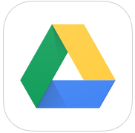 | Google Drive | Cloud store/collaboration | Free of Charge
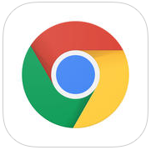 | Google Chrome | Search Engine | Free of Charge
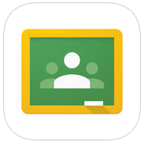 | Google Classroom | Provides features for creating and collecting assignments paperlessly and a platform for direct, real-time feedback with teachers. | Free of Charge
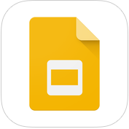 | Google Slides | Create, edit, and collaborate with others on presentations | Free of Charge
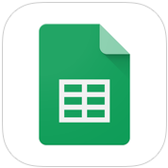 | Google Sheets | Create, edit, and collaborate with others on spreadsheet | Free of Charge
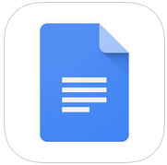 | Google Docs | Create, edit and collaborate with others on documents | Free of Charge
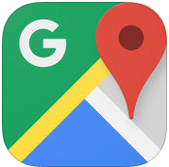 | Google Maps | Navigating maps | Free of Charge
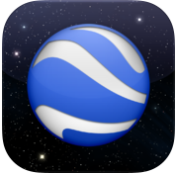 | Google Earth | Navigating earth and space | Free of Charge
 | Keynote | Presentations | Free of Charge
 | iMovie | Creating film/videos | Free of Charge
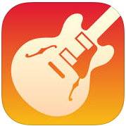 | Garage Band | Music making | Free of Charge
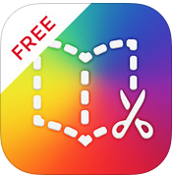 | Book Creator | create your own beautiful iBooks, right on the iPad | Free of Charge
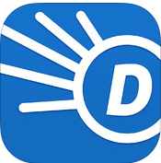 | Dictionary.com | Dictionary | Free of Charge
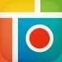 | Pic Collage | Collage creating app | Free of Charge
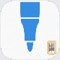 | Sketches school | Drawing, art, poster and display making | Free of Charge
 | Tynker | Coding | Free of charge

