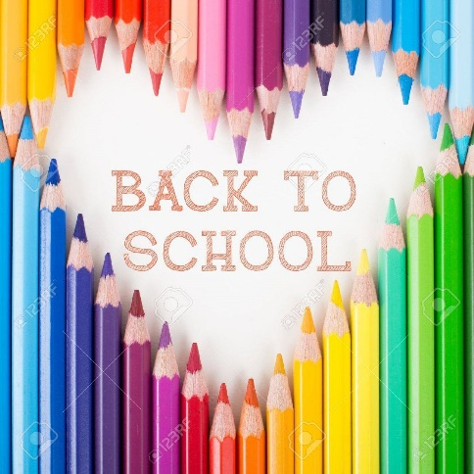
Back to School 2022

Kindergarten
The school will provide your child with many of his/her basic needs for learning when he/she arrives next year.
There are a few things that need to be brought from home for the first day back to school.
Please ensure that all supplies are clearly marked with your child’s name and class.
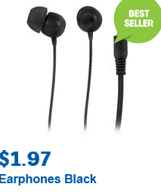
Please send to school:
- 2 large boxes of tissues
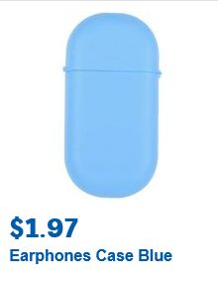
- 6 large glue sticks
- 1 Pkt Whiteboard markers (4 markers)
- A paint shirt
- A library bag
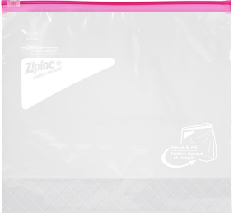
- Earphones (Purchase from Officeworks, K-Mart etc.)
- Earphones case or zip lock bag –
Please ensure the earphones & case are marked with your child’s name
Back to School 2022
Year 1
The school will provide your child with many of his/her basic needs for learning when he/she arrives next year.
There are a few things that need to be brought from home for the first day back to school.
Please ensure that all supplies are clearly marked with your child’s name and class.

Please send to school:
- 1 large boxes of tissues
- 10 large glue sticks
- 1 Pkt Whiteboard markers (4 markers)
- A paint shirt
- A library bag
- Earphones (Purchase from Officeworks, K-Mart etc.)
- Earphones case or zip lock bag – Please ensure the earphones & case are marked with your child’s name
Please ensure the earphones & case are marked with your child’s name
Back to School 2022
Year 2
The school will provide your child with many of his/her basic needs for learning when he/she arrives next year.
There are a few things that need to be brought from home for the first day back to school.
Please ensure that all supplies are clearly marked with your child’s name and class.
Please send to school:
- 2 large boxes of tissues (name on)
- 8 large glue sticks
- A pencil case – reasonable size and cost
- A paint shirt
- A calculator
- A library bag
- Textas/whiteboard markers
- Earphones or headphones (Purchase from Officeworks, K-Mart etc.)
- Earphones case or zip lock bag – Please ensure the
earphones & case are marked with your child’s name
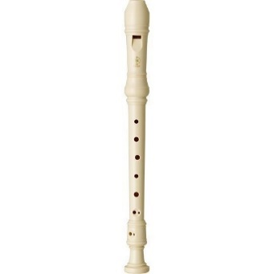
- Yamaha YRS24B Recorder
(Purchase from Turramurra Music, Mall Music, Mona Vale Music, online – (cost between $8.50-$13.99)

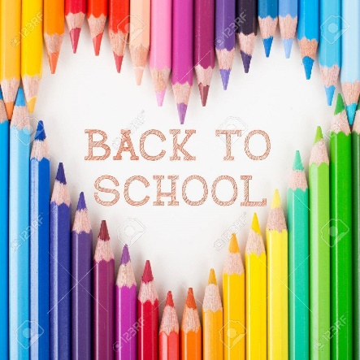
Back to School 2022
Year 3
The school will provide your child with many of his/her basic needs for learning when he/she arrives next year.
There are a few things that need to be brought from home for the first day back to school.
Please ensure that all supplies are clearly marked with your child’s name and class.
Please send to school:
- A pencil case – reasonable size and cost
- Highlighters x 4
- Coloured pencils and pencil sharpener
- Textas
- Scissors
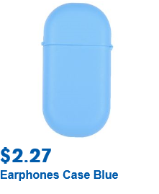
- Eraser
- 2 boxes of tissues
- 8 large glue sticks
- A paint shirt
- A library bag
- Earphones (Purchase from Officeworks, K-Mart etc)
- Earphones case or zip lock bag – Please ensure the
earphones & case are marked with your child’s name
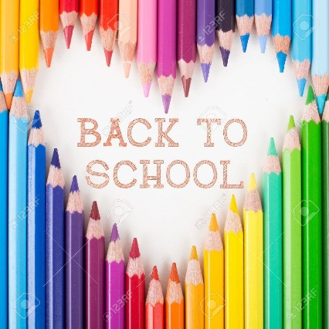
Back to School 2022
Year 4

The school will provide your child with many of his/her basic needs for learning when he/she arrives next year.
There are a few things that need to be brought from home for the first day back to school.
Please ensure that all supplies are clearly marked with your child’s name and class.
Please send to school:
- A small pencil case –
(to hold pencil, eraser, sharpener, glue stick, textas, coloured pencils
- Highlighters x 4
- Coloured pencils
- Pencil sharpener
- Textas
- Scissors
- 2 large boxes of tissues
- 6 large glue sticks
- A paint shirt
- Eraser
- Sturdy gardening gloves (labelled)
- Earphones (Purchase from Officeworks, K-Mart etc)
- Earphones case or zip lock bag – Please ensure the
earphones & case are marked with your child’s name
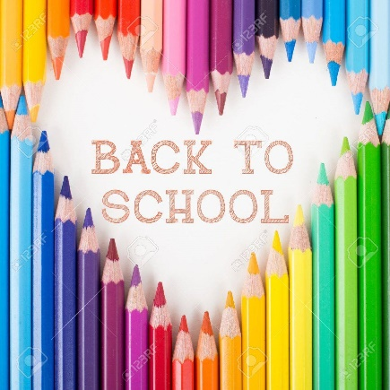
Back to School 2022
Year 5
The school will provide your child with many of his/her basic needs for learning when he/she arrives next year.
There are a few things that need to be brought from home for the first day back to school.
Please ensure that all supplies are clearly marked with your child’s name and class.
Please send to school:
- A pencil case – reasonable size and cost
- Geometry set - including protractor and compass
- Textas
- Highlighters x 4
- Coloured pencils
- Pencil sharpener
- Scissors
- 1 large boxes of tissues
- 5 large glue sticks
- A calculator
- A paint shirt
- Earphones (Purchase from Officeworks, K-Mart etc)
- Earphones case or zip lock bag – Please ensure the
earphones & case are marked with your child’s name
Back to School 2022
Year 6
The school will provide your child with many of his/her basic needs for learning when he/she arrives next year.
There are a few things that need to be brought from home for the first day back to school.
Please ensure that all supplies are clearly marked with your child’s name and class.

Please send to school:
- Oil pastels
- Geometry set - including protractor and compass
- A pencil case - reasonable size and cost
- Textas
- Highlighters x 4
- Whiteboard markers x 4
- Coloured pencils
- Pencil sharpener
- Eraser
- Scissors
- 2 large boxes of tissues
- 4 large glue sticks
- A calculator
- A paint shirt
- Earphones (Purchase from Officeworks, K-Mart etc
- Earphones case or zip lock bag – Please ensure the
earphones & case are marked with your child’s name

